**Running PHPUnit tests after each commit/push**

**Required Flow: -**

Code Commit -> Jenkins Job trigger -> Runs PHPUnit test cases -> Output in a file -> Jenkins parse this file and checks if all cases have passed

-> If Yes, then Code is deployed / Build is complete

-> If No, then code is not deployed / Build fails.

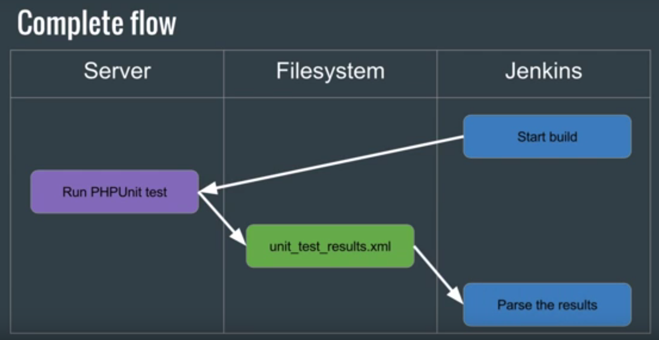

**Sample Project ->**

Demo PHP Class  
  
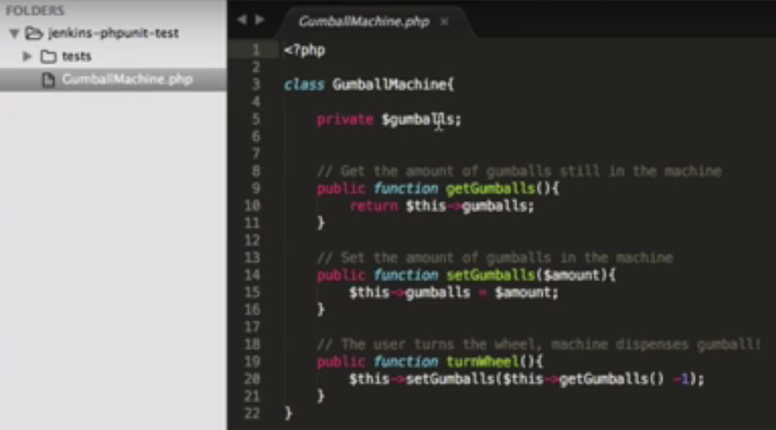

PHPUnit_Framework_TestCase

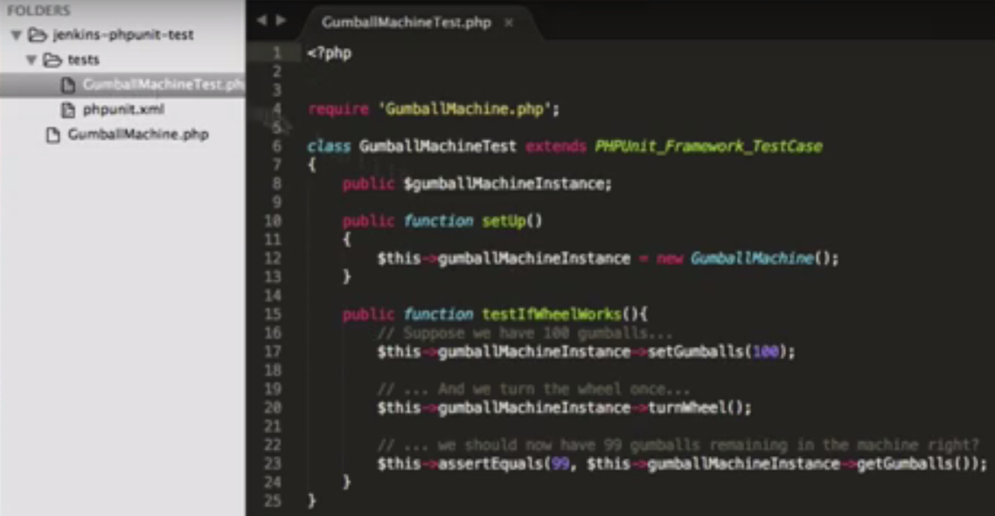

Set it up on Bit Bucket with same Folder structure.

This xml will basically run all the tests in the current directory –

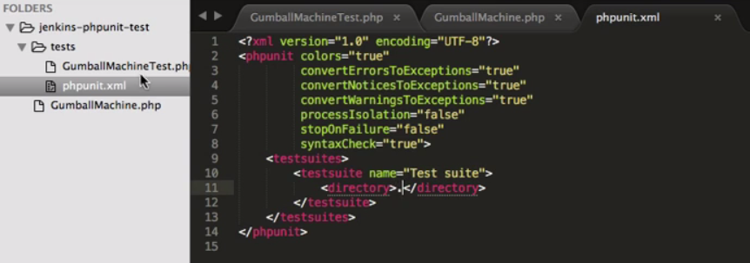

**Set Up Job in Jenkins -**

Required on Jenkins Server ->

1. Install PHPUnit Plugin [Sudo apt-get install phpunit]
2. Verify the JUnit Plugin is installed [JUnit Plugin - JUnit output file(xml)]

Set up Git, Poll SCM()

In the build section –

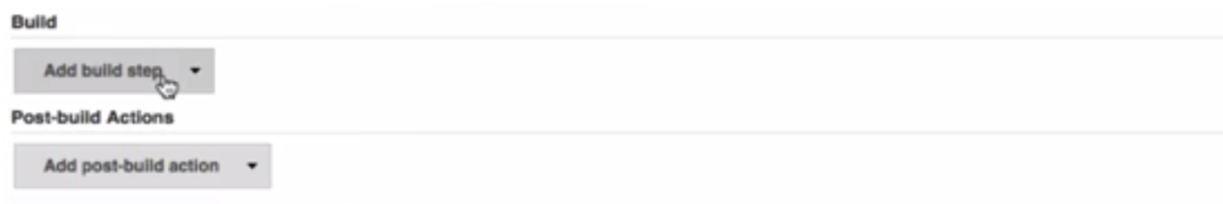

Choose Execute shell

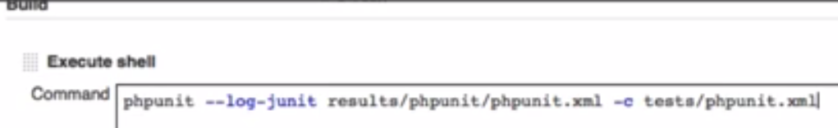

and in Post build action Publish JUnit Test result report, the same path that was set in execute shell step –

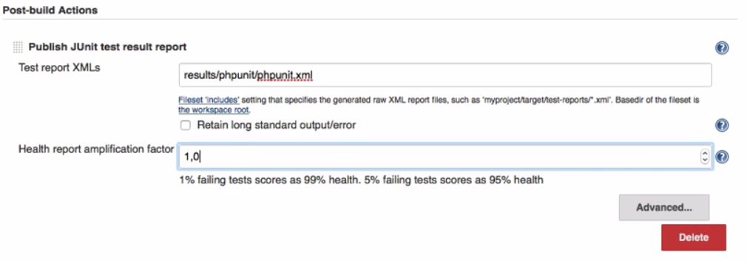

1. signifies the % of test cases that we want the build to PASS in order to succeed.